GSE Algebra 1 Graphing Quadratics Practice 6.2-6.3
Graph each table on the graph provided. Be sure to watch where you are plotting points.
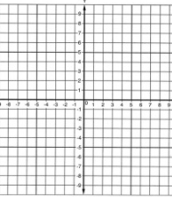
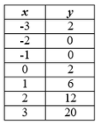

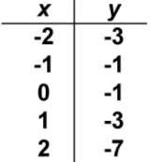

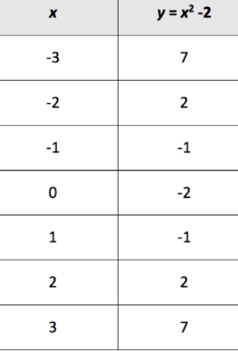

For these two on the back, you need to plug in the values for x in the equation to get your y values.
Then you can graph your points.

x | $$y=-2x^{2}+1$$
-3
-2
-1
0
1
2

x | $$y=x^{2}-3x$$
-3
-2
-1
0
1
2
3

