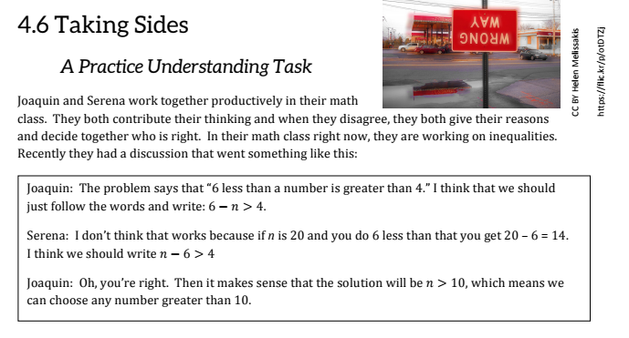
Below are a few more of the conversations that Joaquin and Serena had. Read through each one and decide which one is correct, which one is wrong and explain what you are thinking for each problem.

- The inequality to graph is $x≥-7$.
Joaquin thinks that the graph should have an open dot at -7. | Serena thinks that the graph should have a closed dot at -7.
Explain who is correct and why.

- The problem is $3x+1>0$
Serena says the problem is always true because multiplying a number by 3 and then adding 1 to it makes it greater than 0. | Is she right? Explain why or why not.

- The word problem is “4 greater than x.”
Joaquin says that they should write 4 > x. | Serena says that they should write 4 + x.
Explain who is correct and why.

- Joaquin has this amazing idea about inequalities and equations.
If 45 + 47 = t, then t = 45 + 47 | If 45 + 47 < t , then t < 45 + 47
Is he right? Explain how you know

- Serena got to thinking about what Joaquin said in #4 and thought about similarities and differences. Serena wonders about this equation: $\frac{-x}{3}=4$ and the inequality $\frac{-x}{3}>4$.
What are the similarities in solving these two? | What are the differences in solving these two?

Joaquin solved $-15q≤135$ by adding 15 to both sides. Serena said that was wrong. Who is correct and why? | Joaquin’s solution was $q≤150$. He checked his work by substituting 150 for q in the original inequality. Does this prove that Joaquin is right? Explain why or why not. | Joaquin is still skeptical and believes he is right. Find a number that satisfies his solution but does not satisfy the original inequality.

- Serena is checking her work with Joaquin and finds that they disagree. Here is what Serena wrote:
$$3x+3≤-2x+5$$
$$3x≤-2x+2$$
$$x≤2$$
Is this right or wrong? How do you know? Fix it!

- They are having problems solving the following inequality: $-4(3m-1)≥2(m+3)$. Show them how to do it correctly and list out all the properties you use.

- Do the following have solutions? What are they? How would you graph them on a number line?
4s + 6 $≥6+4s$ | 3r + 5 > 3r – 2 | 4(n + 1) < 4n – 3

- The partners are given a literal inequality ax + b > c to solve for x. Joaquin says it will solve just like an equation. Serena says that they need to be careful because if a is a negative number, then the solution will be different. What do you believe? Solve it.

