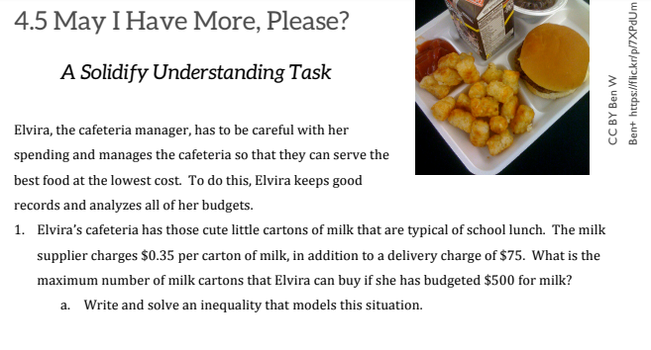
b. Describe in words the quantities that would work in this situation | c. Write your answer in both interval and inequality notation

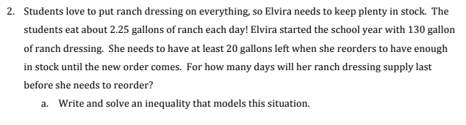

b. Describe in words the quantities that would work in this situation. | c. Write your answer in both interval and inequality notation.
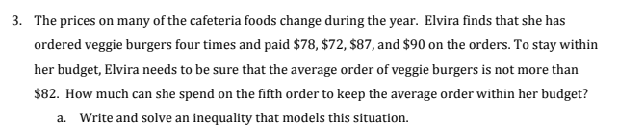

b. Describe in words the quantities that would work in this situation. | c. Write your answer in both interval and inequality notation.
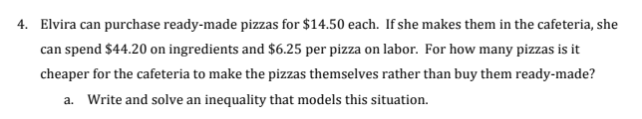

b. Describe in words the quantities that would work in this situation. | c. Write your answer in both interval and inequality notation.

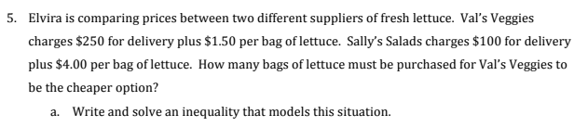

b. Describe in words the quantities that would work in this situation. | c. Write your answer in both interval and inequality notation.

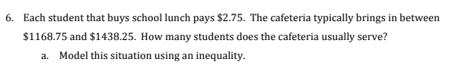

b. Describe in words the quantities that would work in this situation. | c. Write your answer in both interval and inequality notation.

