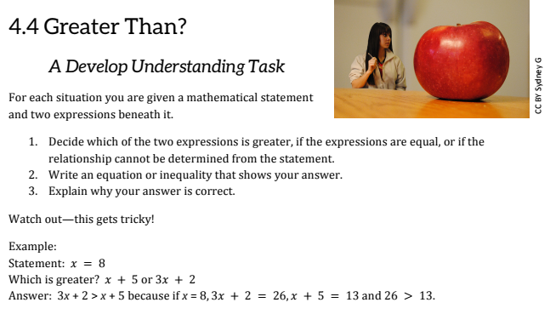

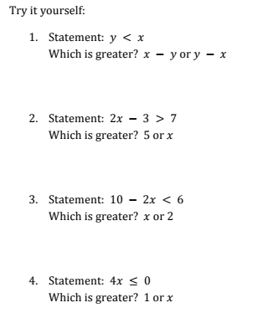

Solve for x

Try to get x alone.

Let’s pick two numbers that make the original statement true.

Now test it out.

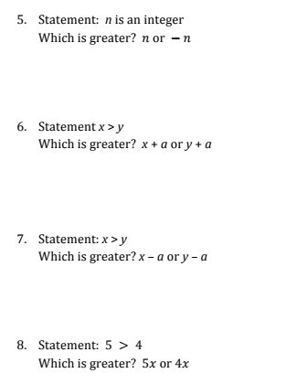

What about 0?

What about 0?

List out what an integer is.

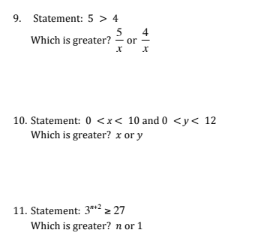

How many 3’s make up 27?

Equal that number to n + 2. Solve for n.

What about when n is negative?

What about 0?

Between what two numbers can **x** be?

Between what two numbers can **y** be?

Are they the same? Where is **y** greater?