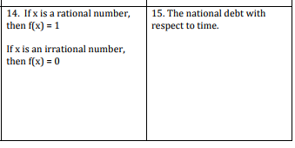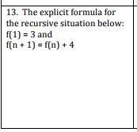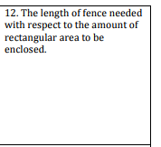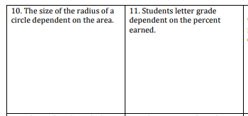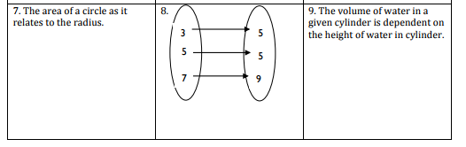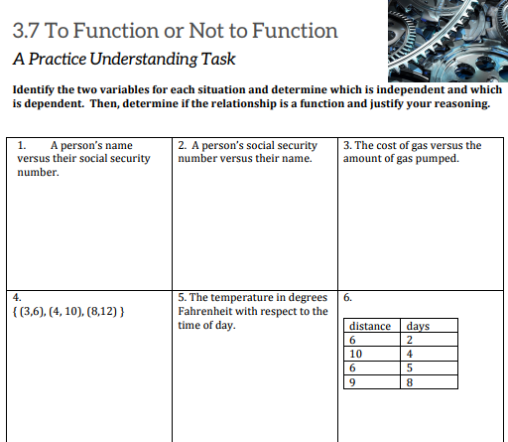

**Independent – x values (DOMAIN)**

**Dependent – y values (RANGE)**

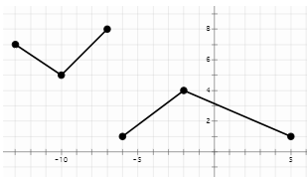 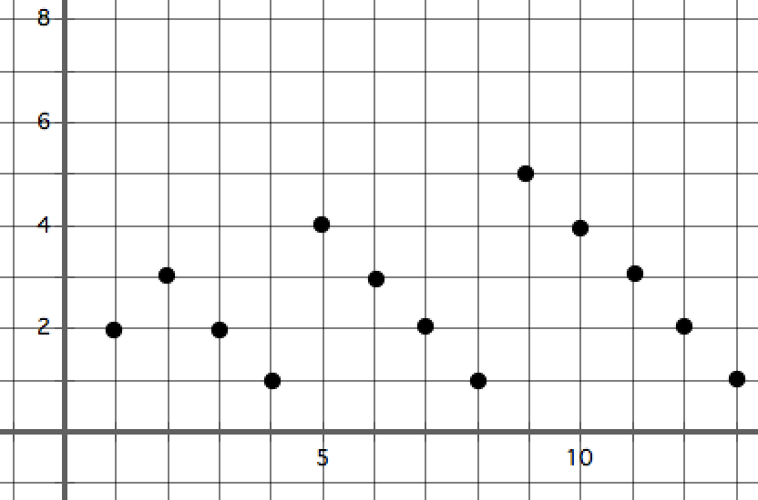

Continuous or discontinuous? Continuous or discontinuous?

What is the domain (independent)? What is the domain (independent)?

What is the range (dependent)?

What is the range (dependent)?

What is the relative max?

**\*\*Function** or **not** a **function**? Remember, if the **X**-**VALUE** **repeats**, it is **NOT** A **FUNCTION**!

These are called mappings – they map one value onto the other

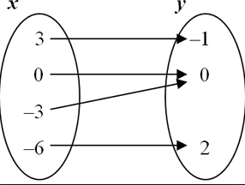 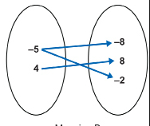

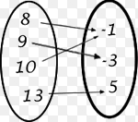 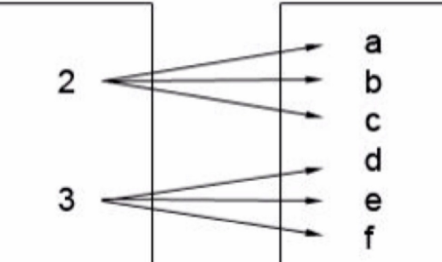

What is the relative min?

Increasing intervals:

Decreasing intervals: