GSE Algebra 1 3.5 - Unit 3 Practice sheet Name: _____________

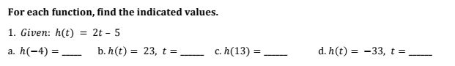

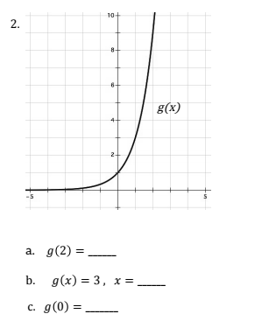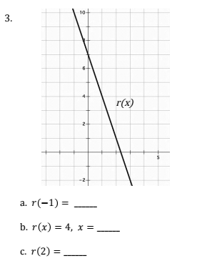

Given the following equations, perform the operations that are required.
$f(x)=4x-1$ $g(x)=\frac{1}{2}x^{2}+4$ $h(x)=-3$ $j(x)=-3x+5$
4)

- f(-1) + j(2) b. f(0) – h(0) c. j(x) = -4, what does x =__________

d. f(x) + j(x) e. j(x) – f(x) f. f(x) = 7, what does x = ____________

g. f(x) = -5, what does x =__________ h. h(x)*j(x)

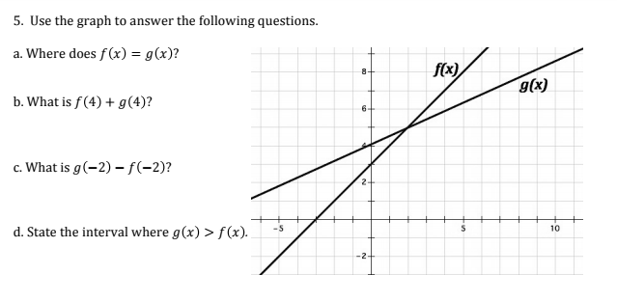

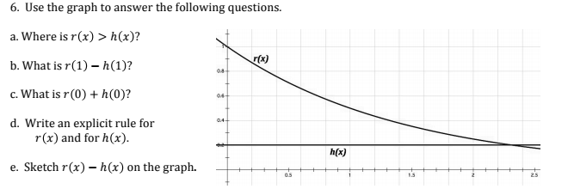

7. How do you know if something is a function or not? Explain for the following examples.
a. Table b. Scenario c. Mapping d. Graph
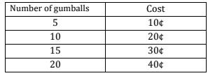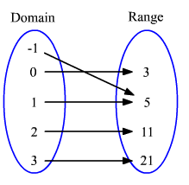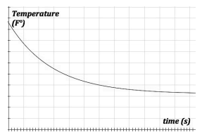
Susan puts exactly $5 a week into her piggy bank. She starts with $14 and wants to see how much she can save if she doesn’t ever spend it.

**Be sure you EXPLAIN in WORDS!
8. Find the domain and range for the following. Be sure to watch the brackets and parentheses.
a. 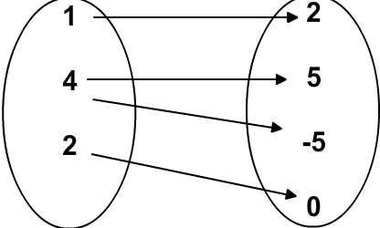 b. 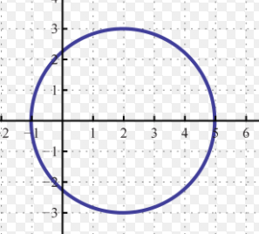 c. 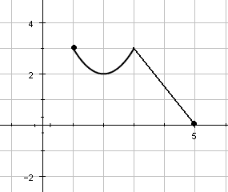
Dom: Range: Dom: Range: Dom: Range:

d. The distance a runner run per day versus the time spent running. e. 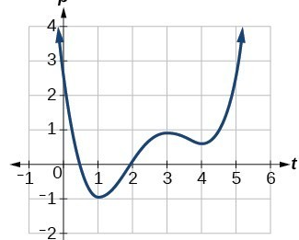
Dom: Range: Dom: Range:

9. Swine Flu is attacking Porkopolis. The function below determins how many people have swine flu where t=time in days and S=the number of people in thousands.
S(t) = 9t – 4
- Find S(4). b. What does S(4) mean?

- Find t when S(t) = 23 mean. d. What does S(t) = 23 mean?

Domain | Range |  | x-intercepts | y-intercepts
Increasing: | 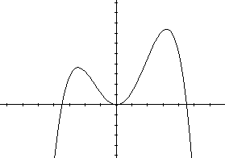 |  | Decreasing: | Function?
 |  |  | Constant: | End Behavior  $$x→-∞ x→∞$$  $$y→ y→$$
Maximums:  Absolute Relative |  | Minimums:  Absolute Relative

