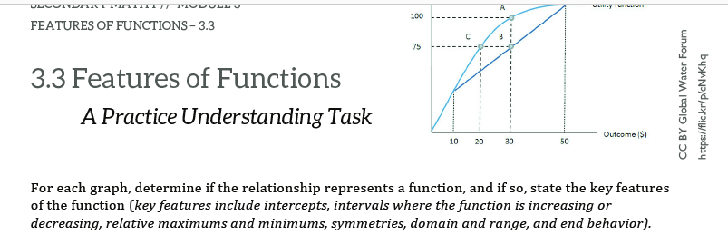

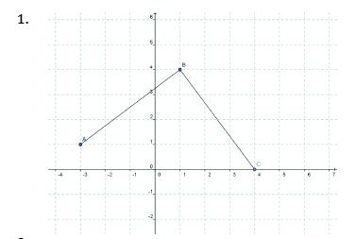

Incr: Decr:

Const: x-int:

y-int: Dom:

Range: Abs. Max:

Abs Min: Rel Max

Rel Min: EB:

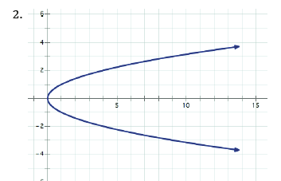

Incr: Decr:

Const: x-int:

y-int: Dom:

Range: Abs. Max:

Abs Min: Rel Max

Rel Min: EB:

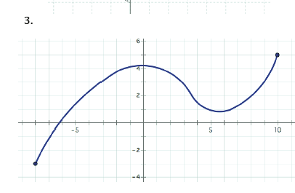

Incr: Decr:

Const: x-int:

y-int: Dom:

Range: Abs. Max:

Abs Min: Rel Max

Rel Min: EB:

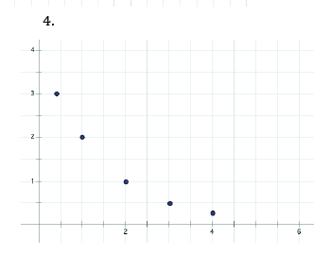

Incr: Decr:

Const: x-int:

y-int: Dom:

Range: Abs. Max:

Abs Min: Rel Max

Rel Min: EB:

Incr: Decr:

Const: x-int:

y-int: Dom:

Range: Abs. Max:

Abs Min: Rel Max

Rel Min: EB:

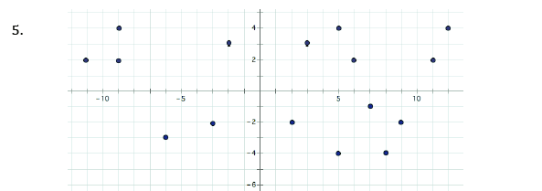

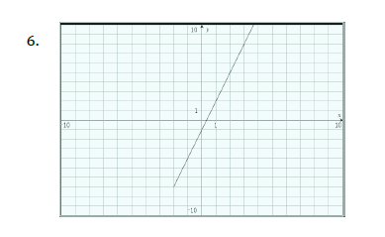

Incr: Decr:

Const: x-int:

y-int: Dom:

Range: Abs. Max:

Abs Min: Rel Max

Rel Min: EB:

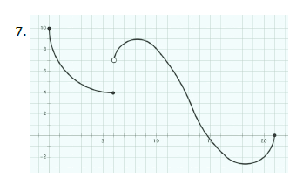

Incr: Decr:

Const: x-int:

y-int: Dom:

Range: Abs. Max:

Abs Min: Rel Max

Rel Min: EB:

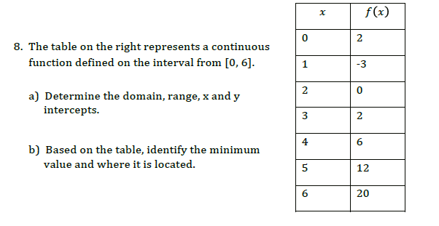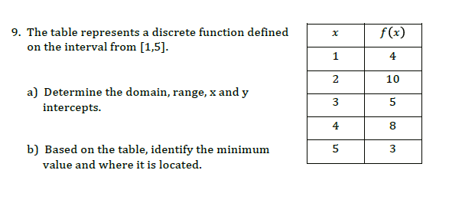

Tell what the **domain** and **range** are for the following scenarios.







|  |  |
| --- | --- |
| x | y |
| 0 |  |
| 1 |  |
| 2 |  |
| 3 |  |
| 4 |  |
| 5 |  |

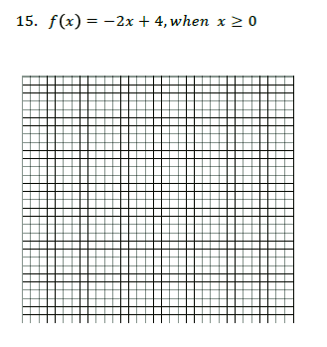

Why did you start the x values at 0 here?

|  |  |
| --- | --- |
| x | y |
| -1 |  |
| 0 |  |
| 1 |  |
| 2 |  |
| 3 |  |
| 4 |  |

