Practice Name: ___________________________________
1.  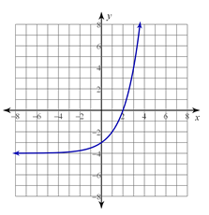 | Circle One: Linear Exponential Neither  Circle One: Discrete Continuous
2.  $$y=2x+4$$ | Circle One: Linear Exponential Neither  Circle One: Discrete Continuous
3.  x y  0 5  2 11  4 17  6 23 | Circle One: Linear Exponential Neither  Circle One: Discrete Continuous  Equation: ____________________________
4. You invest $4,000 in a company and earn a 5% profit at the end of each year. | Circle One: Linear Exponential Neither  Circle One: Discrete Continuous  Equation: ______________________________
5. Joe has a jar of 300 Reece’s pieces. Every hour he reaches in the jar and gets ten pieces and eats them quickly. | Circle One: Linear Exponential Neither  Circle One: Discrete Continuous  Equation: ______________________________
6.  x y  0 4  1 12  2 36  3 108 | Circle One: Linear Exponential Neither  Circle One: Discrete Continuous  Equation: ______________________________
7.  Cashiers Items scanned  1 20  2 40  3 60  4 80 | Circle One: Linear Exponential Neither  Circle One: Discrete Continuous  Equation: ______________________________
8.  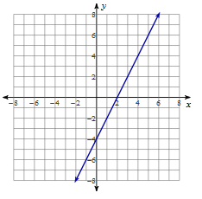 | Circle One: Linear Exponential Neither  Circle One: Discrete Continuous  Equation: _____________________________  (hint: make a table from the points on the graph)
9.  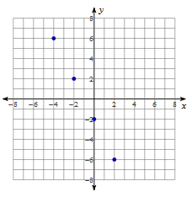 | Circle One: Linear Exponential Neither  Circle One: Discrete Continuous  Equation: _____________________________  (hint: make a table from the points on the graph)
10.  Year Profit  0 100  1 200  2 400  3 800 | Circle One: Linear Exponential Neither  Circle One: Discrete Continuous  Equation: ______________________________

